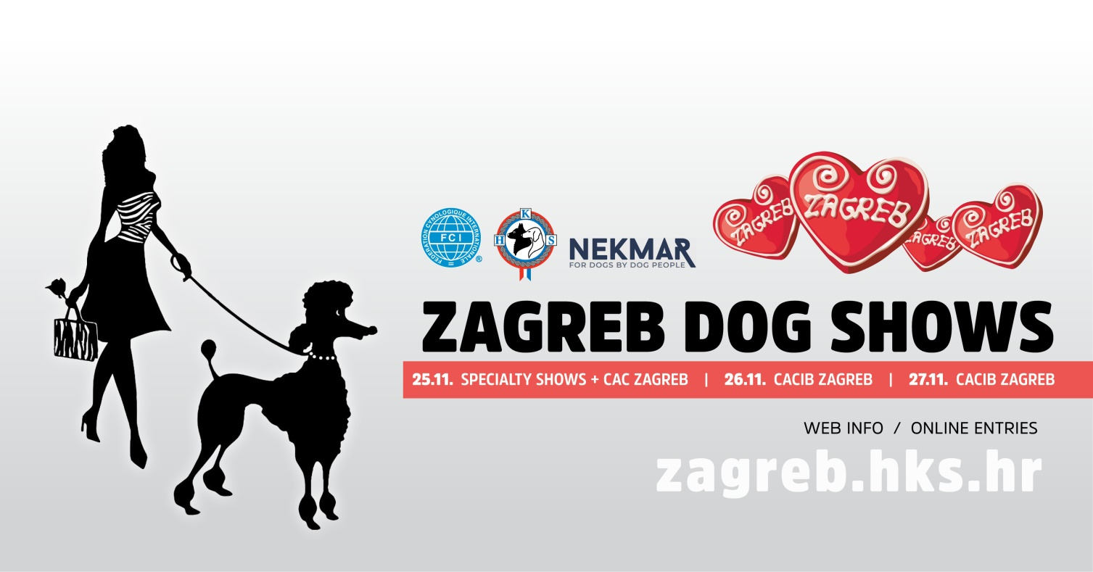
Dear partners!
We are free to offer business promotional areas to promote and sell your products in the space of a minimum of 9 m², to the square footage that fits your needs and desires. The tenant gets the required quadrature UNBUILT space, and space equipment. If you are interested you must built it on your own.
We deliver you the contract, so if you are interested in cooperation, please send us a stamped, no later than November 5th , 2022 on following e-mail adress:
priredbe@hks.hr

Lessor HRVATSKI KINOLOŠKI SAVEZ
ILICA 61
HR – 10000 ZAGREB
APPLICATION FORM
Lessee | Company Name:
 | Contact person:
 | Address:
 | City:
 | Zip code:
 | Country:
 | Phone:
 | Mobile phone:
 | Fax:
 | e-mail:
 | WAT No:
Invoice adress  (if different from dispatch adress) | Address:
 | City:
 | Zip code:
 | e-mail:

STAND RENTAL – CONTRACT

SPECIALTY AND CACIB ZAGREB – November from 25th to 27th ,2022

ZAGREB FAIR – GPS: 45° 46' 53,83“ N - 15° 58' 39,99“ E

THE LAST DEADLINE FOR SUBMISSION OF CONTRACT: 05.11.2022

1. | The lessor shall transfer the lessee to use the office space on the SPECIALTY AND DOUBLE INTERNATIONAL DOG SHOWS – CACIB ZAGEB  There is space:  FRONTLINE m FEET DEEP m STAND HEIGHT TOTAL sqm PRICE sqm TOTAL excluded WAT FOR ALL 3 DAYS MARK square meters  3 3 2,5 m 9 sqm 350 KN 3.150 KN  4 3 2,5 m 12 sqm 350 KN 4.200 KN  5 3 2,5 m 15 sqm 350 KN 5.250 KN  6 3 2,5 m 18 sqm 350 KN 6.300 KN  7 3 2,5 m 21 sqm 350 KN 7.350 KN  8 3 2,5 m 24 sqm 350 KN 8.400 KN  9 3 2,5 m 27 sqm 350 KN 9.450 KN  OR WRITE TO DEMAND  3 2,5 m 350 KN  USE OF THE ELECTRICITY SUPPLY:  500 KN YES: NO:

2. | Lessee agrees to pay an agreed amount of compensation, latest by 15.11.2022, so his signature waives any right of appeal if the tenant, after the payment deadline specified in this article, this agreement is deemed void.

Date: ______________ 2022

Croatian Kennel Club:  Tajana Matejčić | The lessee:

